**Exercise No:5**

**Date:14-10-2020**

**Aim:**

**To print Missing character to make a string pangram using python .**

**Program:**

**a = input ()**

**a= set (a.strip ())**

**a. remove(chr(32))**

**b="abcdefghijklmnopqrstuvwxyz"**

**b=set(b)**

**b=b.difference(a)**

**b=list(b)**

**b. sort()**

**print("".join(b))**

**Link:**

[**http://103.53.53.18/mod/vpl/forms/edit.php?id=235&userid=1684**](http://103.53.53.18/mod/vpl/forms/edit.php?id=235&userid=1684)

**Output:**

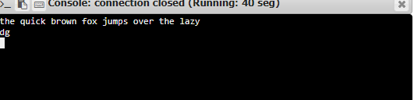

**Result:**

**Thus, the Missing character is printed to**

**Make a string pangram using python.**